**Artificial intelligence**

**Name : Roaa Nasser Hassan Heliel**

**ID:327**

**Group:3**

**Section:15**

**DR:Ahmed Biomy**

**Application brief**

* What is Artificial Intelligence (AI)?

Artificial intelligence (AI) is a wide-ranging branch of computer science concerned with building smart machines capable of performing tasks that typically require human intelligence. AI is an interdisciplinary science with multiple approaches, but advancements in machine learning and deep learning are creating a paradigm shift in virtually every sector of the tech industry.

* **HOW DOES ARTIFICIAL INTELLIGENCE WORK?**

Less than a decade after breaking the Nazi encryption machine Enigma and helping the Allied Forces win World War II, mathematician Alan Turing changed history a second time with a simple question: "Can machines think?"

Turing's paper "Computing Machinery and Intelligence" (1950), and its subsequent Turing Test, established the fundamental goal and vision of artificial intelligence.

At its core, AI is the branch of computer science that aims to answer Turing's question in the affirmative. It is the endeavor to replicate or simulate human intelligence in machines.

The expansive goal of artificial intelligence has given rise to many questions and debates. So much so, that no singular definition of the field is universally accepted.

The major limitation in defining AI as simply "building machines that are intelligent" is that it doesn't actually explain what artificial intelligence is? What makes a machine intelligent?

In their groundbreaking textbook Artificial Intelligence: A Modern Approach, authors Stuart Russell and Peter Norvig approach the question by unifying their work around the theme of intelligent agents in machines. With this in mind, AI is "the study of agents that receive percepts from the environment and perform actions." (Russel and Norvig viii)

Norvig and Russell go on to explore four different approaches that have historically defined the field of AI:

Thinking humanly

Thinking rationally

Acting humanly

Acting rationally

The first two ideas concern thought processes and reasoning, while the others deal with behavior. Norvig and Russell focus particularly on rational agents that act to achieve the best outcome, noting "all the skills needed for the Turing Test also allow an agent to act rationally." (Russel and Norvig 4).

Patrick Winston, the Ford professor of artificial intelligence and computer science at MIT, defines AI as "algorithms enabled by constraints, exposed by representations that support models targeted at loops that tie thinking, perception and action together."

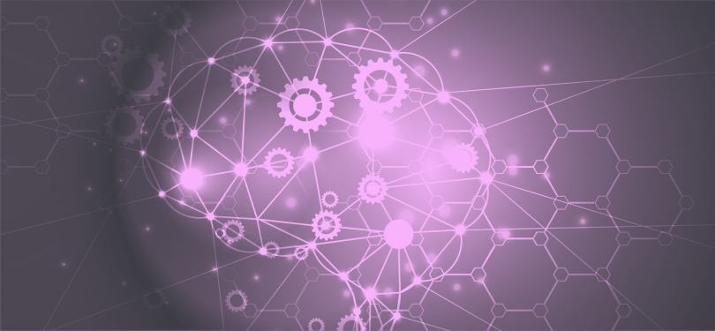

**HOW IS AI USED?**

artificial intelligence generally falls under two broad categories:

* **Narrow AI:** Sometimes referred to as "Weak AI," this kind of artificial intelligence operates within a limited context and is a simulation of human intelligence. Narrow AI is often focused on performing a single task extremely well and while these machines may seem intelligent, they are operating under far more constraints and limitations than even the most basic human intelligence.
* **Artificial General Intelligence (AGI)**: AGI, sometimes referred to as "Strong AI," is the kind of artificial intelligence we see in the movies, like the robots from *Westworld* or Data from *Star Trek: The Next Generation*. AGI is a machine with general intelligence and, much like a human being, it can apply that intelligence to solve any problem.

**ARTIFICIAL INTELLIGENCE Application**

* Smart assistants (like Siri and Alexa)
* Disease mapping and prediction tools
* Manufacturing and drone robots
* Optimized, personalized healthcare treatment recommendations
* Conversational bots for marketing and customer service
* Robo-advisors for stock trading
* Spam filters on email
* Social media monitoring tools for dangerous content or false news
* Song or TV show recommendations from Spotify and Netflix

**Narrow Artificial Intelligence**

Narrow AI is all around us and is easily the most successful realization of artificial intelligence to date. With its focus on performing specific tasks, Narrow AI has experienced numerous breakthroughs in the last decade that have had "significant societal benefits and have contributed to the economic vitality of the nation," according to "Preparing for the Future of Artificial Intelligence," a 2016 report released by the Obama Administration.

A few examples of Narrow AI include:

* Google search
* Image recognition software
* Siri, Alexa and other personal assistants
* Self-driving cars
* IBM's Watson

**Machine Learning & Deep Learning**

Much of Narrow AI is powered by breakthroughs in [machine learning](https://www.expertsystem.com/machine-learning-definition/) and [deep learning](https://www.mathworks.com/discovery/deep-learning.html). Understanding the difference between artificial intelligence, machine learning and deep learning can be confusing. Venture capitalist Frank Chen [provides a good overview](https://a16z.com/2016/06/10/ai-deep-learning-machines/) of how to distinguish between them, noting:

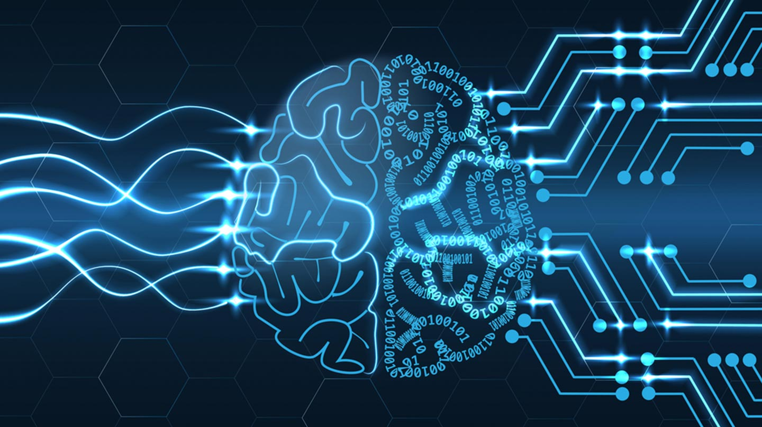

Screenshot frome project

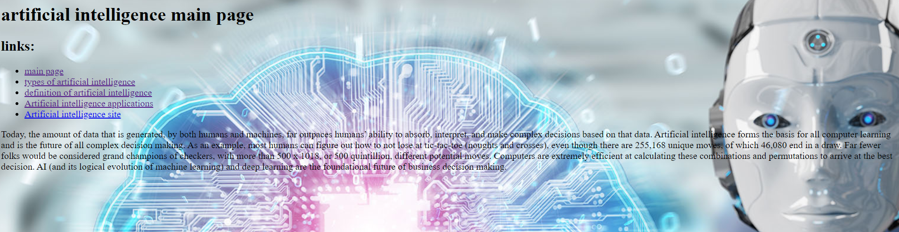

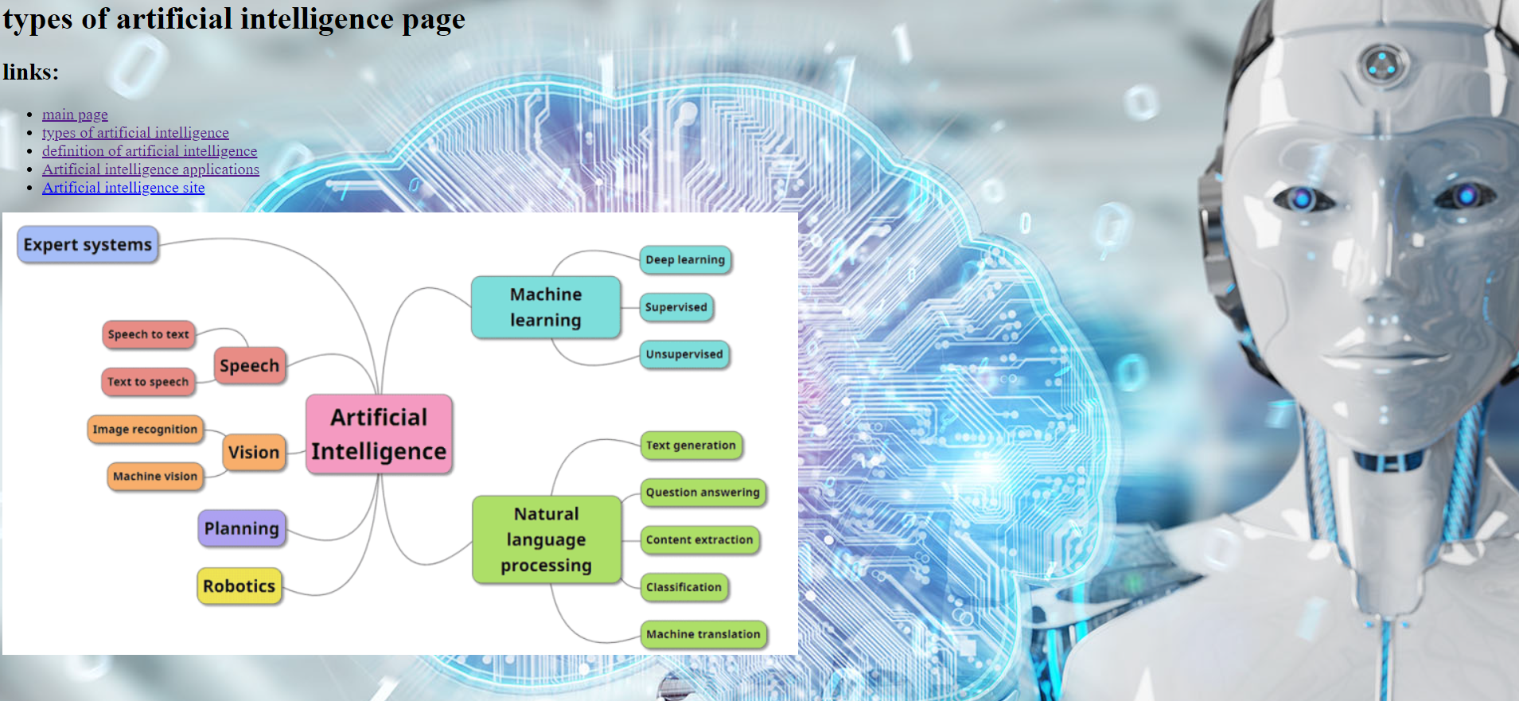

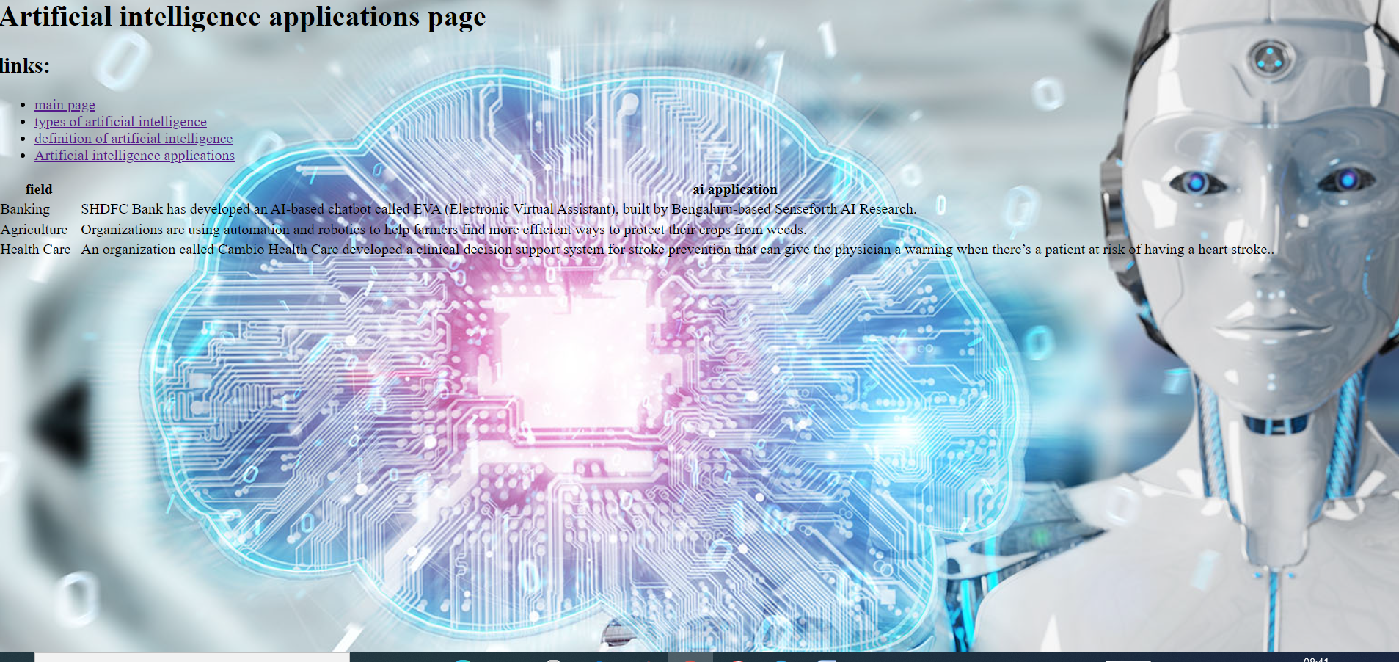

**Source code**

